# Assignment No. 8

1. **Create Database PCCOE**

use PCCOE

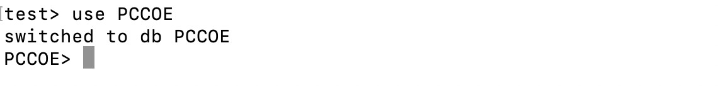

1. **Create Collections - Teachers & Students** db.createCollection("Teachers") db.createCollection("Students")

db.Teachers.insertMany([

{ Tname: "Praveen", dno: 101, dname: "Computer", experience: 8, salary: 12000, date_of_joining: "2018-06-15" },

{ Tname: "Rahul", dno: 102, dname: "IT", experience: 5, salary: 11000, date_of_joining: "2019-07-20" },

{ Tname: "Anjali", dno: 103, dname: "E&TC", experience: 7, salary: 9000, date_of_joining: "2017-03-10" }

])

db.Students.insertMany([

{ Sname: "Amit", roll_no: 1, class: "SE" },

{ Sname: "Rahul", roll_no: 2, class: "TE" },

{ Sname: "xyz", roll_no: 3, class: "BE" }

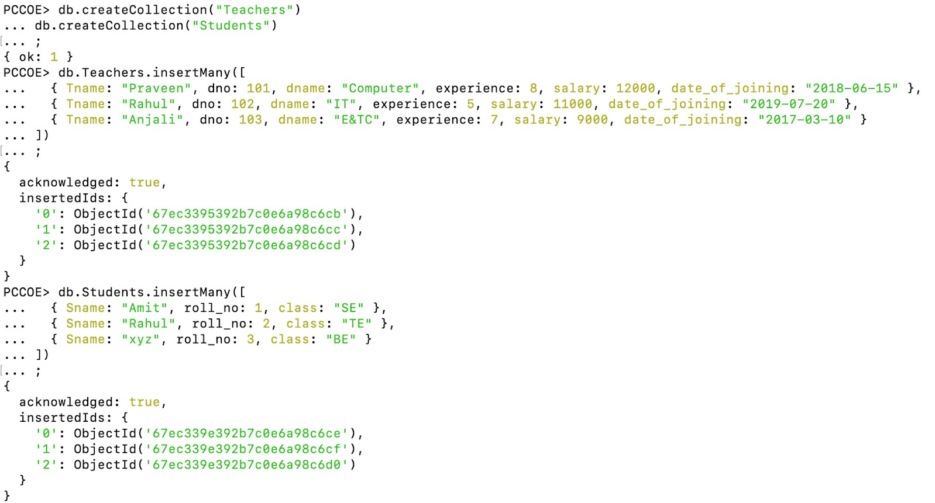])

# Find the information about all teachers

db.Teachers.find().pretty()

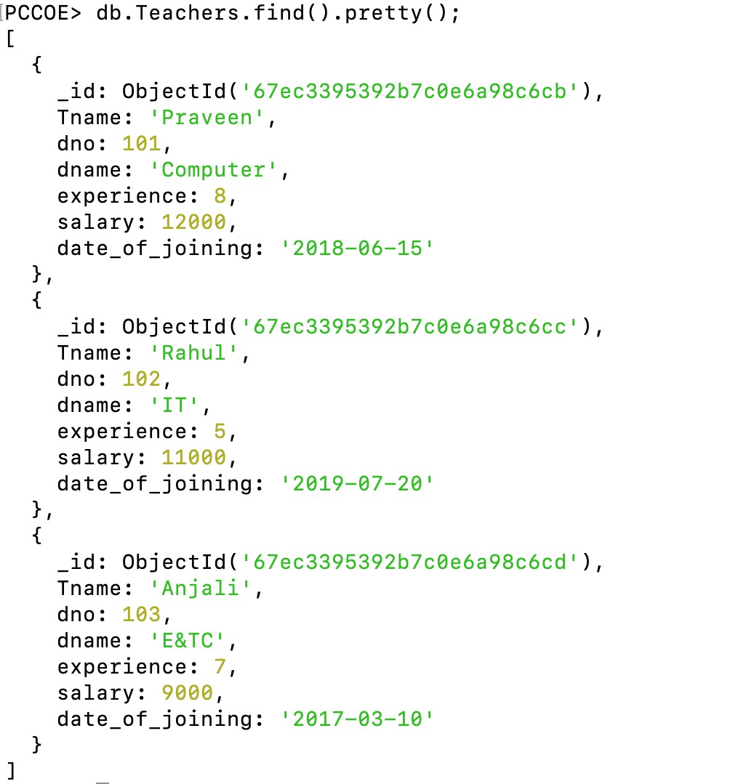

# Find the information about all teachers of Computer department

db.Teachers.find({ dname: "Computer" }).pretty()

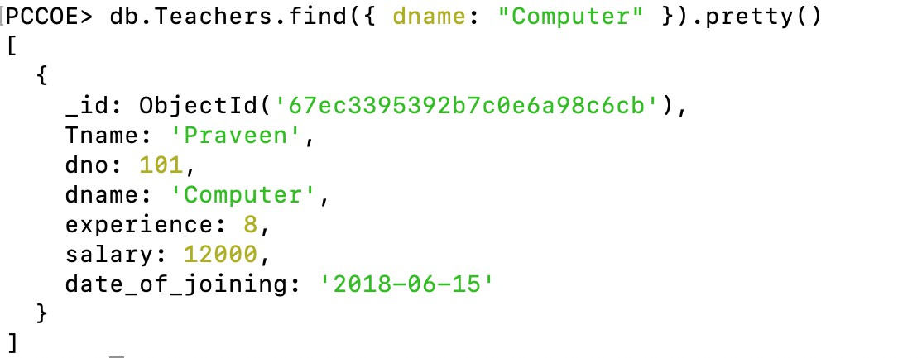

# Find the information about all teachers of Computer, IT, and E&TC department

db.Teachers.find({ dname: { $in: ["Computer", "IT", "E&TC"] } }).pretty()

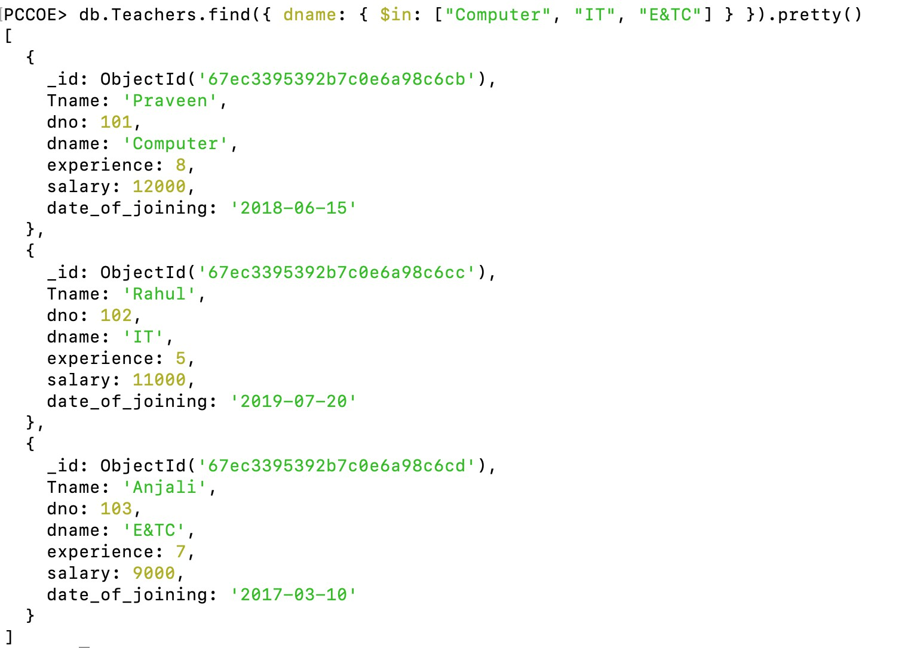

# Find the information about all teachers of Computer, IT, and E&TC department having salary ≥ 10000

db.Teachers.find({ dname: { $in: ["Computer", "IT", "E&TC"] }, salary: { $gte: 10000 }

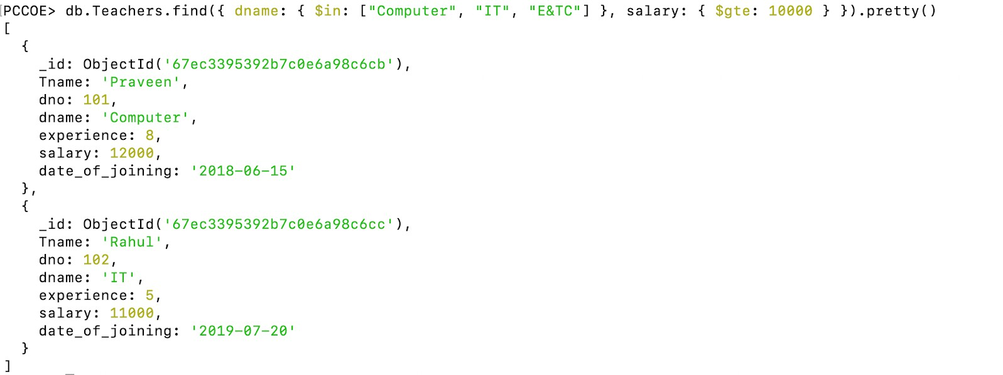}).pretty()

# Find the student information having roll_no = 2 or Sname = "xyz"

db.Students.find({ $or: [{ roll_no: 2 }, { Sname: "xyz" }] }).pretty()

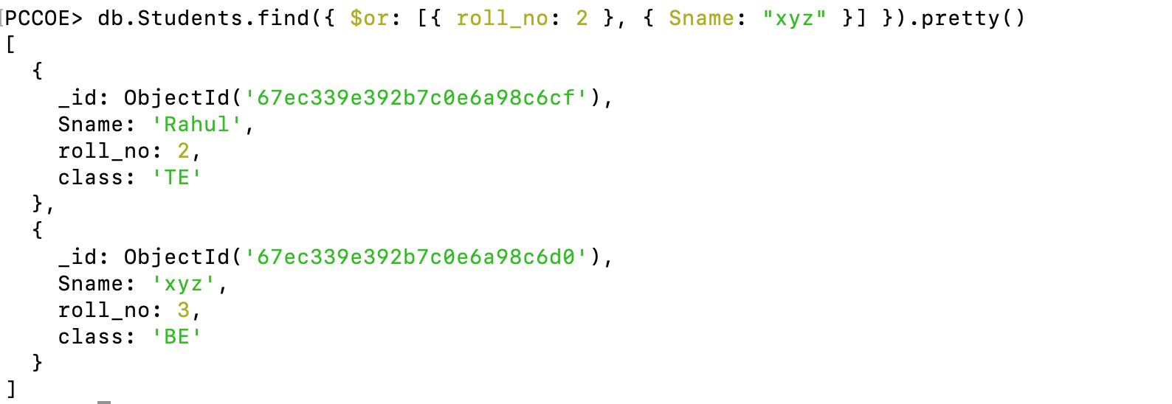

# Update the experience of teacher Praveen to 10 years, insert if not exists

db.Teachers.updateOne(

{ Tname: "Praveen" },

{ $set: { experience: 10 } },

{ upsert: true }

) 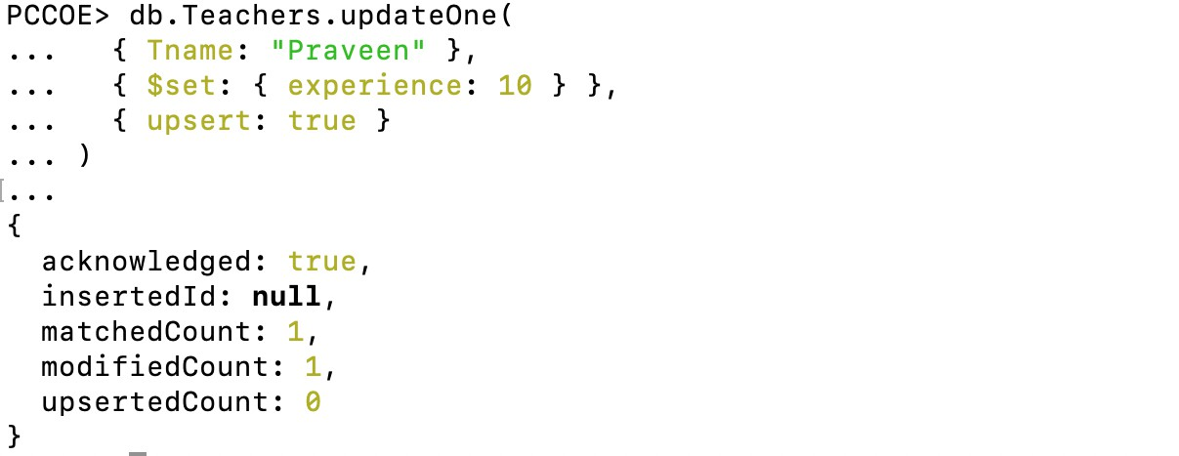

# Update the department of all teachers working in IT department to COMP

db.Teachers.updateMany(

{ dname: "IT" },

{ $set: { dname: "COMP" } }

)



# Find the teacher's name and their experience

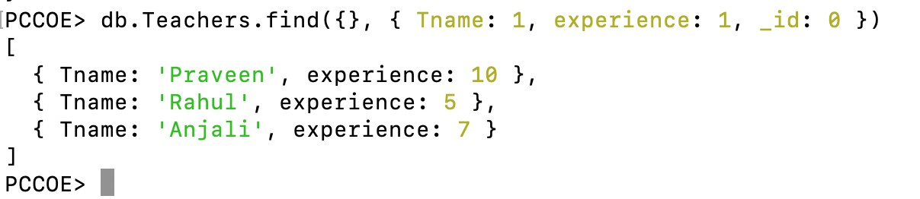db.Teachers.find({}, { Tname: 1, experience: 1, _id: 0 })

# Using Save() method insert one entry in Department collection

db.Departments.insertOne({ dno: 104, dname: "Mechanical" })

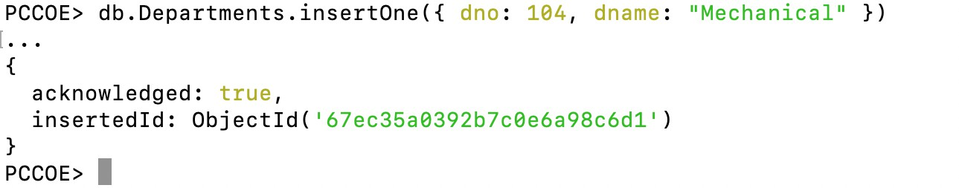

# Using Save() method change the department of teacher Praveen to IT

db.Teachers.insertOne({ Tname: "Praveen", dname: "IT", experience: 10,

salary: 12000,

date_of_joining: "2018-06-15"

})

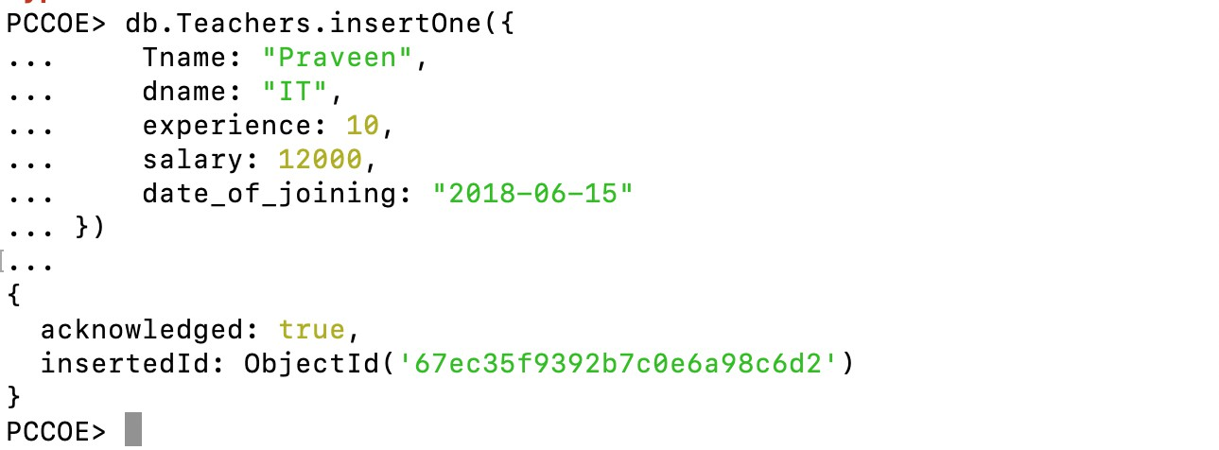

# Delete all documents from Teachers collection having IT department

db.Teachers.deleteMany({ dname: "IT" })

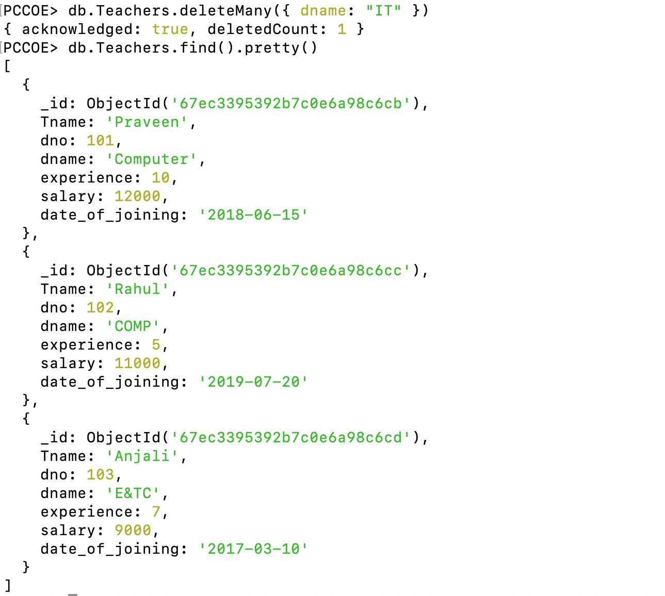

# Display the first 3 documents in Teachers collection in ascending order

db.Teachers.find().sort({ Tname: 1 }).limit(3).pretty()

